UNIT TEST #2: Living in a Global World - Geography in the 21st Century
Study Guide

In-Class Review Date: Thursday, November 19th, 2015 Study Guide Due Date: Friday, November 20th, 2015

Unit Test Date: Monday, November 23rd AND Tuesday, November 24^{t,}

SECTION 1: Vocabulary

You should be able to define and apply the following terms:

LOCATION: Location is a place’s position on earth.

ABSOLUTE LOCATION: Absolute location is a place’s exact position on earth, often based on its latitude and longitude.

RELATIVE LOCATION: Relative location is a place’s position when compared to the locations of other places.

LATITUDE: Lines of latitude run from east to west and measure the distance north or south of the equator.

LONGITUDE: Lines of longitude run from north to south and measure the distance east or west of the Prime Meridian.

EQUATOR: The equator is an imaginary line on the Earth's surface in between the North Pole and South Pole, dividing the Earth into the Northern Hemisphere and Southern Hemisphere.

PRIME MERIDIAN: The Prime Meridian is located at zero degrees longitude and passes through Greenwich, England. All longitude is measured relative to the prime meridian.

PLACE: Place is the physical and human features of a location.

REGION: A region is an area with common features that make it different from other areas.

MOVEMENT: Movement is the way people, goods, and ideas travel from place to place.

HUMAN-ENVIRONMENT INTERACTION: Human-Environment Interaction refers to how people change their environment and how people change the way they live because of their environment.

POLITICAL MAP: A political map shows political features, such as national or state boundaries, capital cities and other major cities.

DISTORTION: On a map, distortion is the misrepresentation of shape, area, distance, or direction of or between geographic features when compared to their true measurements on the curved surface of the earth.

SECTION 2: Map Projections

- Explain why it is impossible to display a map of the world on a flat surface without stretching or shrinking some places.

- How does an Equal Area Projection represent the world differently than a Mercator Projection?

- If you were writing a geography textbook, which projection would you use to represent the world? Identify advantages and disadvantages of your choice.

SECTION 3: Location - Longitude & Latitude

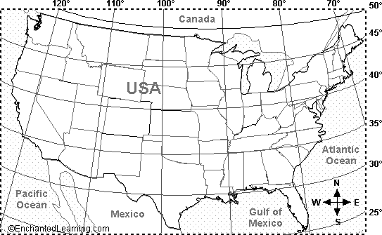

- Using the map above, identify the approximate longitude and latitude of the state of Connecticut.

Longitude: _________ ° N / S / E / W (Circle one) Latitude: _________ ° N / S / E / W (Circle one)

- Describe the relative location of the state of Connecticut.

- What is the difference between location and place? Explain the difference using the state of Connecticut as an example.

- Connecticut is located in the _____________________________ region of the United States. It is located to the _____________________ (N / S / E / W) of Florida and to the ______________________ of California.

SECTION 4: Human-Environment Interaction & Movement

- As we discussed throughout this unit, humans adapt to, modify, and depend on their environment. Provide an example of how YOU adapt to, modify, and depend on the environment in which you live.

I adapt to my environment by… | I modify my environment by… | I depend on my environment by…

- Identify a current event that is an example of humans interacting with the environment. Explain whether the current event represents an example of people adapting to, modifying or depending on the environment.

- Consider the article Junior Scholastic article, “Desperation At Sea”. How would you describe migrants’ journey from the Middle East to Europe? Why are migrants and refugees willing to make this dangerous journey?

- Consider the New York Times article, “New to Being Dry, the South Struggles to Adapt”. A) According to the article, what solutions were proposed to lessen the effects of the drought and/or prevent future drought-related emergencies? B) How would YOU address the issue? Would you adapt and/or modify the environment. What steps would you take to lessen the effects of the water shortage?

SECTION 5: Reading Maps

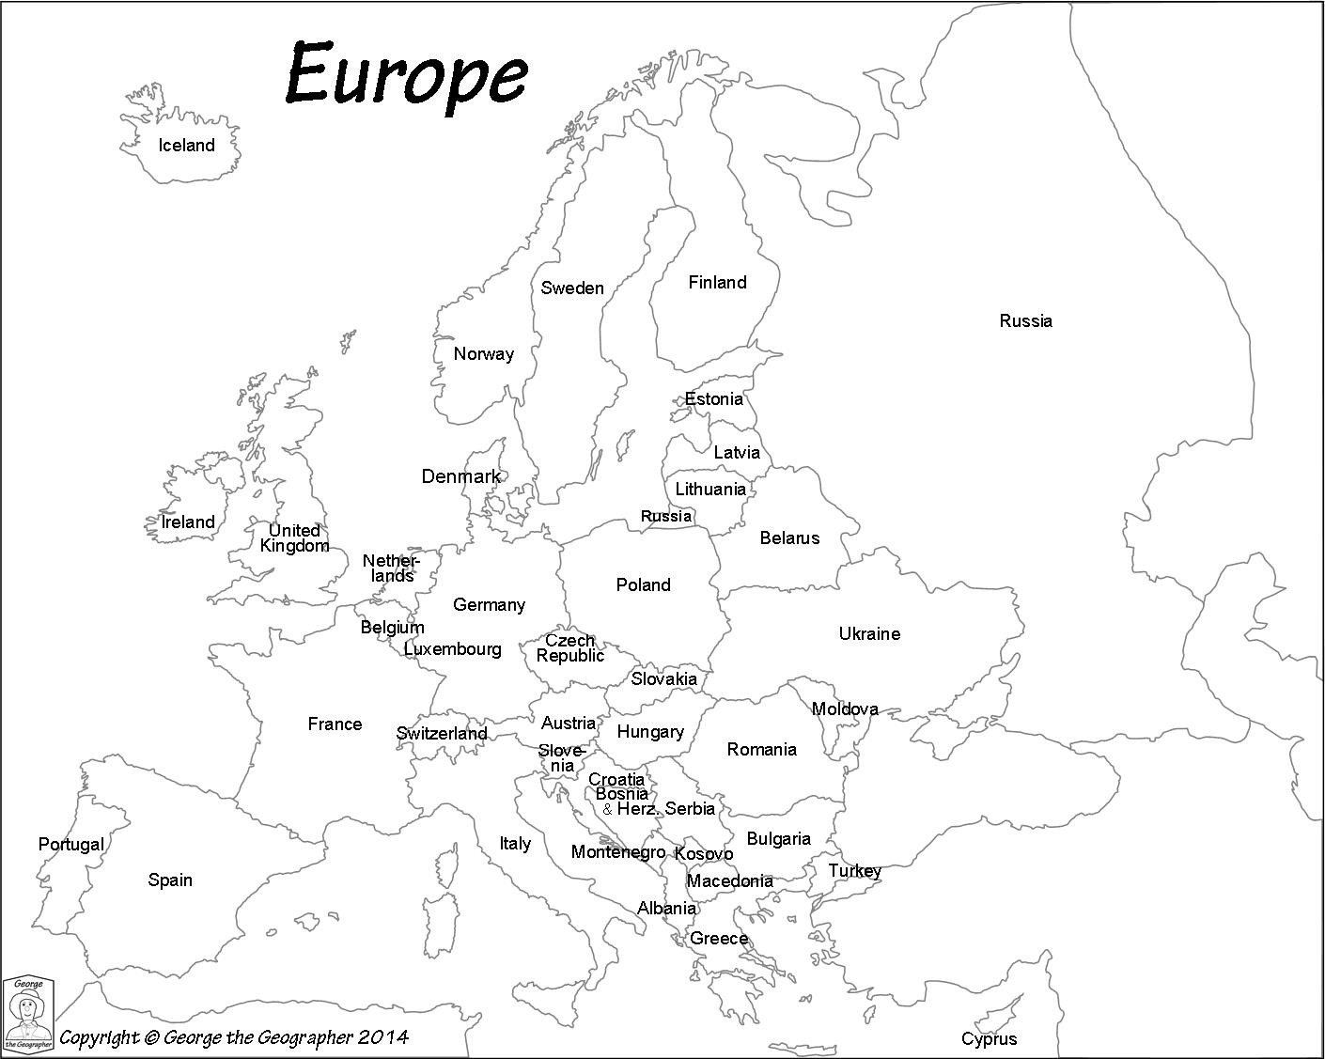

- Consider the political map above. A) What does a solid black line on the map represent? B) List the nations that border Hungary to the north, south, east, and west. C) Identify the Atlantic Ocean and the Mediterranean Sea, and draw a compass rose on the map to indicate direction.

A) ________________________________________________________________________________________

B) North: _______________ South:_________________ East: _____________ West: ________________

Use the blank space below for notes as you prepare for the test:

