Name____________________________Date______________Period___

Exploring the Five Themes of Geography
Webquest

PART I: Click here to view a New York Times slideshow about surfing in an unlikely place – North Carolina. Be sure to look at all the pictures and read all of the text!

After you have navigated the site and read the text, make the connections to each of the Five Themes of Geography.

a. Absolute Location: Identify North Carolina on this map by drawing a star.
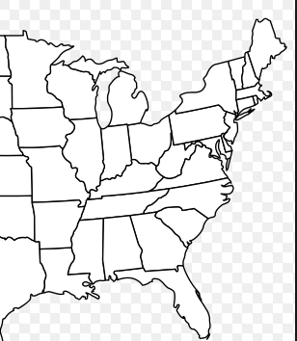

b. Relative Location. Describe the location of North Carolina in relation to Connecticut (i.e. Texas is southwest of Connecticut.)

c. Place. Describe this place based on what you saw in the slideshow. What is it like? (Include the natural environment and the human culture.)

d. Region. What region is it in (i.e. northeast, southwest, northwest, southeast)? Is it in a region that you typically think of when you think of surfing? Where is another surfing region? Explain.

e. Human-Environment Interaction. How are humans using the land? How is the land affecting humans?

f. Movement. How are people, things, or ideas moving?

PART II: Choose one of the three articles below.
After Irene, Vermont Kids Travel Across a Mountain to Get to School
Alien Wasps Attacking Birds in Hawai'i
Increasing Piracy in Somali Waters

Read your selected article. Then, decide which one of the five themes is most significant in your article. You must to choose just ONE! Describe where in your article you identified the theme, and explain why you think it is the most important in this article.

Part III: Click here to view a collection of National Geographic images. Choose THREE of the images, and be sure to identify which images you are discussing. Explain how each image relates to the five themes. List as many relevant themes for each image as you can, and explain your reasoning.

Image #______

Image #_______

Image #_______

